Introduction:

Welcome to this presentation on the cost of living in US cities. With the completion of the Data Analytic Visualization Bootcamp, many of you may be considering relocating to a new city for job opportunities. However, it's important to not only consider the job market, but also the overall cost of living and quality of life in a particular city.

In this presentation, we will explore the cost of living in several US cities, with a focus on the independent variables of transportation, food, and housing. Determining which cities offer the lowest cost of living and the highest quality of life.

By the end of this presentation, you will have a better understanding of the cost of living in different US cities, and you will be better equipped to make a decision about which city to move to for your job search. Let's get started.

The data and collection

The data for this presentation was collected using a combination of CSV files and API. The main source of data was from the "Global Cost of Living" dataset on Kaggle, which provided a wealth of information on the cost of living in various cities around the world. However, as the dataset included data from multiple countries, we had to extract only the United States data. We did this by filtering out rows that did not pertain to the US, which brought the number of rows down from 5000 to 1073.

Once we had extracted the US data, we then had to clean and prepare the data for analysis. This involved merging columns and filtering out any empty rows which reduced the final city count to 313. Additionally, as the columns were originally labeled with integers, we renamed them to more meaningful names, using a legend to make it easier to understand the data.

One limitation of the "Global Cost of Living" dataset was that it did not provide the State for each City. To overcome this limitation, we used the Open Weather API to look up the City names by States. This allowed us to include State information in our analysis, which made it easier to compare the cost of living across different regions of the US.

Data Analysis

The data was analyzed using the Python programming language in a Jupyter Notebook. We used several libraries such as Panda, JSON, and Matplotlib to clean, manipulate and visualize the data. To understand the patterns in the data, we created various charts and graphs using Matplotlib and Excel pivot tables.

One of the key observations was that living in the city center was noticeably more expensive than living outside the city center. For example, in New York, the median monthly cost of a 3-bedroom apartment in the city center was $7145, while it was $4278 outside the city center, which is a difference of 40.1%. Similarly, in Miami, the median monthly cost of a 3-bedroom apartment in the city center was $4620.17, while it was $3175 outside the city center, which is a difference of 31.4%. These findings suggest that if you're looking for more affordable housing options, it may be worth considering living outside the city center. When completing an analysis in Pandas, the average difference between living in the city and outside of the city was 17.7%



We also observed that the costs of utilities and internet connections were relatively consistent across US cities, with most cities falling within a range of $100 to $150 per month.

However, it's important to note that median salary of New York was 5900 and Miami was 4150. Therefore, living in the city center would be a challenge for those earning the median salary.

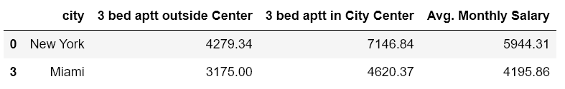

According to the Bureau of Labor Statistics (BLS), the median usual weekly earnings of full-time wage and salary workers in the United States was $936 in the third quarter of 2022, equivalent to a monthly salary of approximately $4,064. However, this is just an average and the actual amount can be significantly higher or lower.

Cost of Living Comparison

The study found that the top 50 most expensive cities in the US are primarily located in California (23 cities) and Florida (8 cities). Other states with a significant number of expensive cities include Washington, Virginia, and New Jersey. Housing expenses drive cost of living and geography is the main determining factor, with cities on the North East and Western Coast being the most expensive.

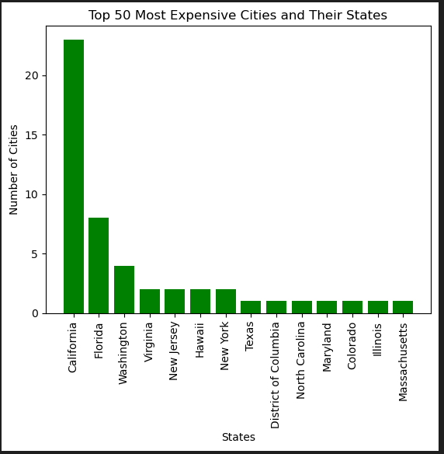 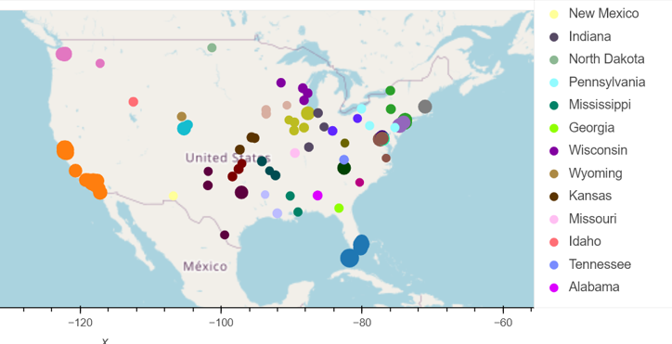

The top 5 expensive states are Hawaii, California, Washington, New York, and Massachusetts. The most expensive cities were Key West, Boca Raton, Red Wood City, New York, and Mountain View. Housing was the main driver of cost of living, accounting for 73% of expenses. The least expensive states were West Virginia, Mississippi, Arkansas, North Dakota, and Missouri, while the least expensive cities were Shreveport, Dubuque, Sumter, Suffolk, and Russellville. These findings can be useful for people planning to move or budgeting for future.

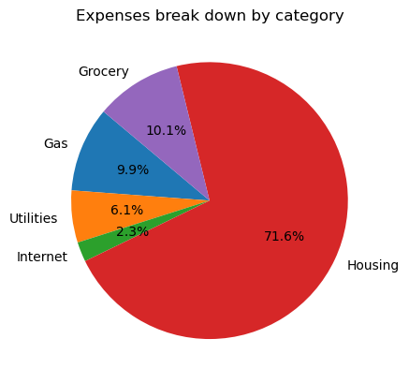 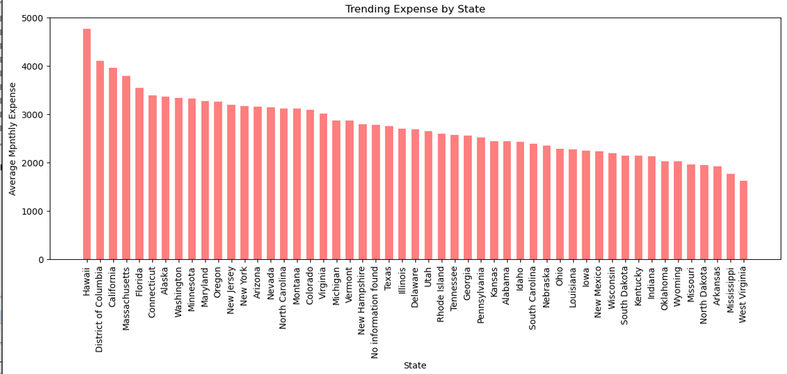

Conclusion

There were several conclusions that we made from the analysis of this data set. The first conclusion was that housing cost were the most significant factor between cities with a high cost of living and cities with a low cost of living. In addition, housing location within a city makes a large impact on the total cost with living outside of the city center being nearly 18% lower than inside the city center. Secondly, states in the interior of the country had a lower cost of living and may be good choices to consider to maintain a lower cost of living compared to states such as California and Florida. This analysis could be paired with additional data such as healthcare options, weather, availability of entertainment such as museums, theater, or even state parks so refine options best suited for us within a given cost of living range.